Final Report- Exploring Bike Segments in Idaho

1. Choose an investigation and identify pre-existing sources of data that can address a particular data science goal: (7%)

A. Choose, and state, the goal and reasons why the data sets were chosen and how they were found and managed, Min. 3-4 sentences

* + The dataset was generated to find statistical data about bike trails around Idaho. Our motivation stemmed from a desire to identify the best bike trails in Idaho and gain valuable insights to address our research hypotheses. We selected this dataset for several reasons: the rich data content, diverse sourcing, and easy availability and accessibility. The dataset was obtained by using Strava’s API; data was extracted and organized based on our research goals. Due to the dataset being relatively clean, we did not have to spend significant amounts of time removing and altering columns.

B. Document and discuss the data formats and any metadata standards/ conventions in use, and the method(s) of discovery and access and how they helped or hindered the process, Min. 3-4 sentences

* Originally, the dataset was downloaded from a Strava database in JSON format. We chose to convert it into a CSV, as this better suited our group’s needs and analysis methods. Since the data was extracted from an API, there was no metadata included. To remedy this issue, we used Dublin Core Metadata Standards to create a functional framework for our dataset. This aided in keeping the dataset and metadata more organized. However, it hindered the process as it posed the additional challenge of having to create and manage the metadata. Discovery and access were facilitated by Strava’s API, which made the data collection process significantly more involved than downloading a CSV data file. This process required that the group pay careful attention to the data integrity and formatting during conversions from JSON format to CSV format.

2. Data Analysis (12%)

A. Develop and state two particular questions/hypotheses related to the goal of the investigation and that can be answered using the datasets under consideration. Design an analysis study (preliminary, full and post) to answer these questions and document the analysis design, Min. 3-4 sentences (3%)

* Is there a correlation between athletes’ star ratings of a trail and factors such as distance, average grade, maximum grade, elevation changes, and effort counts?
  + Pre-Analysis:
    - Data Exploration: Begin by exploring the dataset to understand the distribution and factors such as distance, average grade, maximum grade, elevation changes, star counts (how many athletes “like” a route), and athlete counts.
    - Feature Engineering: Derive new features such as star rate (star count/ athlete count) and star present (binary: 0 for no stars, 1 for at least 1 star) to represent athletes’ star ratings for trails
  + Full Analysis:
    - Model Selection: Choose appropriate models for the binary classification problem, such as logistic regression, KNN, SVM, binary neural network classifier, decision tree classifier, or random forest to analyze the correlation between star rating and trail factors.
    - Data Splitting: Split the dataset into training and testing sets for model training and evaluation.
    - Model Training and Evaluation: Train the selected modeling using the training data and evaluate its performance using the metrics accuracy, precision, recall, and f1-score.
    - Correlation Analysis: Analyze the correlation between athletes’ stars and trail factors using statistical methods.
  + Post-Analysis:
    - Model Validations: We validated the trained models by utilizing the testing dataset to ensure their generalization and reliability in predicting star ratings based on trail factors. This involved assessing the models’ performance metrics.
    - Insights and Recommendations: The key insights on the connections between star trails and factors are intriguing, as they reveal that factors such as effort count, athlete count and elevation height yield significant influence in predicting the presence of stars. Future studies can use this insight to predict if a star is present at other trails that are not within Strava’s database.
* Which cycling routes exhibit the highest level of competition among athletes?
  + Pre-Analysis:
    - Defining Competitiveness Criteria: This criteria was based on distance, average grade, total elevation gain, and fastest time. This will serve as the foundation for predicting the level of competitiveness.
    - Exploratory Data Analysis (EDA): Conduct EDA to understand the distribution and relationships of the competitiveness criteria. This step involves visualizations such as histograms, scatterplots, and correlation matrices to identify how variables relate to each other and if outliers are present.
  + Full Analysis:
    - Model Development: Develop an Ordinary Least Squares (OLS) linear regression model using competitive criteria as input features and the route’s fastest time (in seconds) as the output variable. Include a constant term model to capture the baseline relationship.
    - Model Evaluation: Using the R squared metric of ‘0.947’, the OLS model explains 95% of the variance seen in the fastest time variable. This step validates how well the model fits the data so that it can be used to predict competitiveness.
    - Competitiveness Scoring: Utilize the trained model to predict competitive scores for each cycling route based on calculated differences between predicted and actual fastest times. Assign competitive scores on a scale from –1 (being least competitive) to +1 (being the most competitive).
    - Identify Highly Competitive Routes: Identify and rank cycling routes with the highest level of competition among athletes based on competitiveness scores. Visualize ranking by generating a KML file to view routes on google earth and to provide a clear understanding of competitive routes.
  + Post-Analysis:
    - Validation: The model’s results were validated by comparing the predicted competitiveness scores with specific observations and intuition. It can be seen in the KML output that routes closer to downtown areas generally have more competitive record times than routes which are farther into the foothills. It is also seen that cycling routes on paved roads are usually averagely competitive compared to other routes. This process of visually verifying competitiveness scores ensured the model’s accuracy in assessing route competitiveness.
    - Insights and Recommendations: Key insights from the analysis revealed the most and least competitive routes, highlighting factors influencing competitiveness such as route characteristics (distance, elevation, geographic location, etc.) and athlete performance metrics. Additionally, outliers can be identified, providing valuable insights into potential areas for further investigation.

B. You need to use at least one machine learning method in your data analysis. Only using linear regression is not enough for the assignment. Provide a description of the choice of tools/ methods used or a description of any code or scripts written, and describe how your results were stored and managed, min. 3-4 sentences (4%)

* Several models were compared to the Strava data set to satisfy the need of diverse data analysis. Our team employed logistic regression, K-nearest neighbors (KNN), support vector machines (SVM), neural network classifier, decision tree classifier, and random forest classifier models. Random forests and decision trees provided excellent insights into features of importance and were trivial to interpret. Classifiers used were stored in the same .ipynb file for easy comparison when interpreting differences. Output of data frames and results were also standardized for each type to keep a clean output for fair comparisons. Our overall use of python proved to be excellent as data science libraries could easily be imported.

C. Perform the analysis in a form that can be validated and describe the steps and results you took to ensure this validation, min. 5-6 sentences. (5%)

* To ensure validity of our analysis, we followed several steps before beginning. First the dataset was divided into training and testing data and then the model was evaluated on the new unseen data. We then verified the performance of each model using cross-validation metrics to determine effectiveness. By validating our decision tree through examining its structure and implementation, we understood how it made predictions. Although a neural network was considered it didn't give insight as it converged quickly and overfitted the training data, leaving it to be less feasible compared to other analysis options. Reducing the max depth hyperparameter for decision trees and forest models mitigated overfitting. Another way we analyzed our data was using an ordinary least squares (OLS) linear regression, comparing our predicted y values to our actual y values. To validate our model's performance, the accuracy of our predictions was assessed using metrics such as the coefficient of determination (R-Squared), and the residuals to ensure they followed a normal distribution. Through this, we were able to determine a scale of competitivity. A positive difference suggested that the predicted y values were higher than the actual ones, indicating a more competitive environment. This approach allowed us to validate the analysis method and derive meaningful insights from the data with confidence.

3. Presentation/ Visualization (6%)

A. Prepare presentations/ visualizations of both the data (and any metadata, information) and the results of the analysis and describe them, min. 2-3 sentences. (2%)

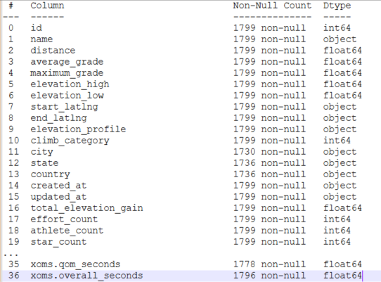

1.1 Figure containing data frame from Strava.csv database file

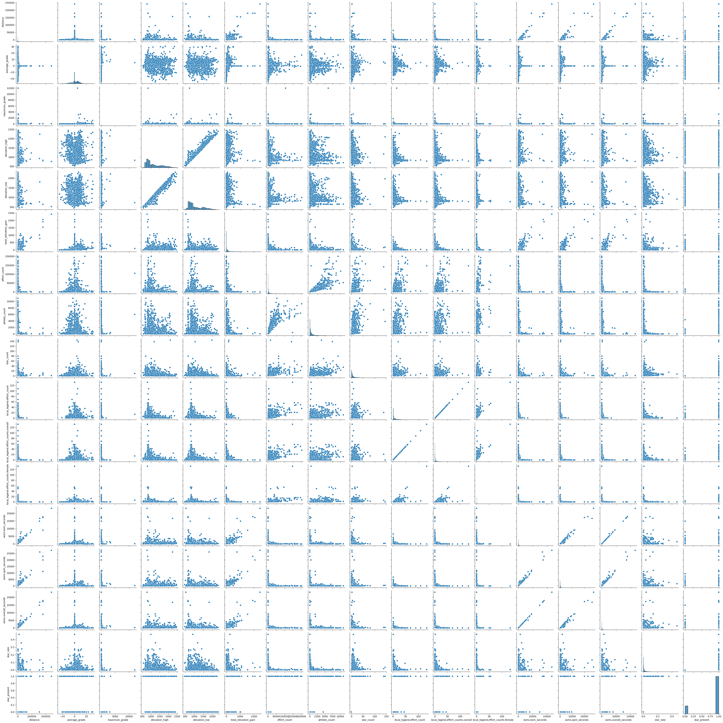

1.2 Pair plots comparing variables found in data frame to each other.

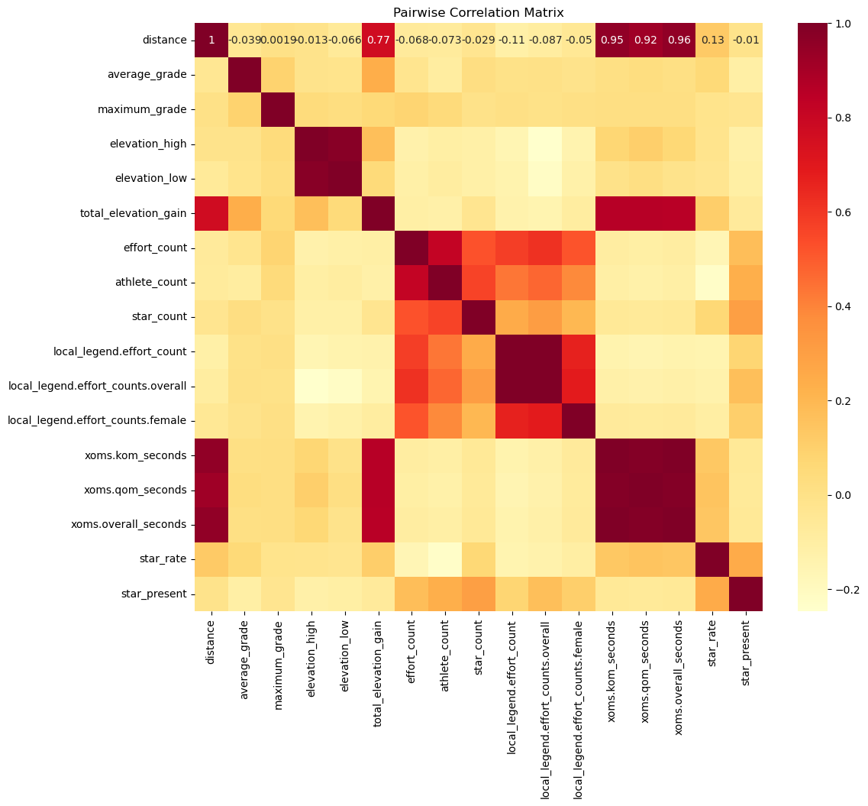

1.3 Correlation matrix created from Strava data frame. We can utilize this matrix to determine correlation between variables much easier than pair plots.

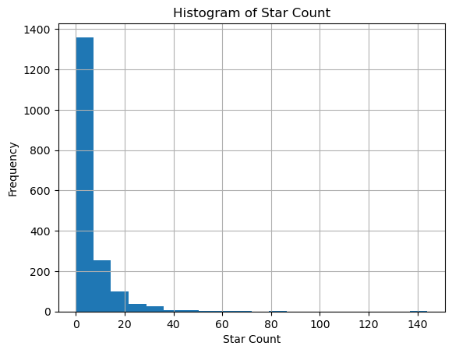

1.4 Histogram comparing the two variables of “Start Count” and “Frequency of visits” showing direct linkage between the two variables.

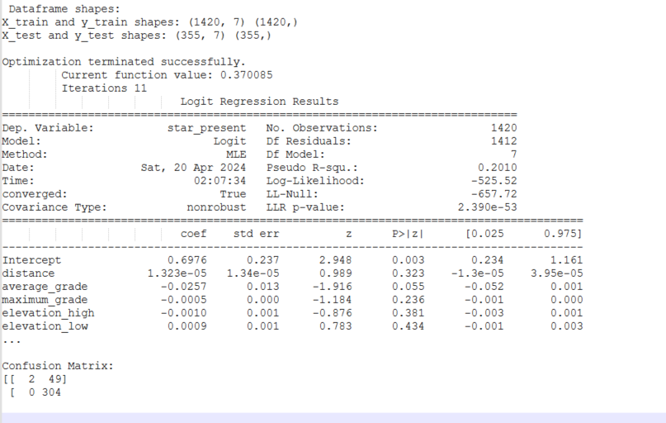

1.5 Output of first Logisitic regression model applied as well as a confusion matrix.

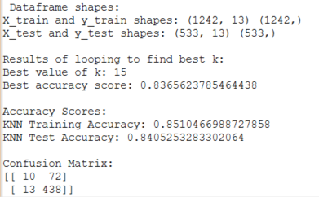

1.6 Output of KNN Classifier Model on dataset.

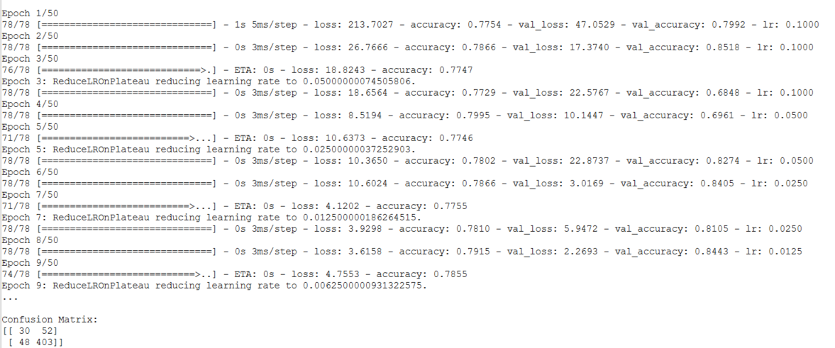

1.7 Output of Neural Networks applied to our dataset.

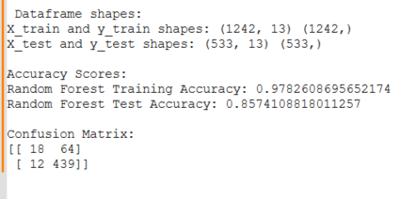

1.8 Output of Random Forest Classifier.

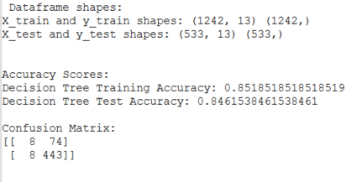

1.9 Random Forest Classification Report

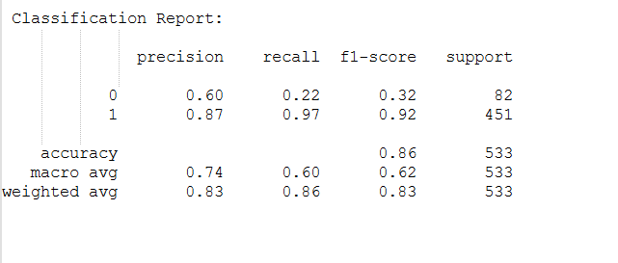

1.10 Output of Decision Tree Classifier.

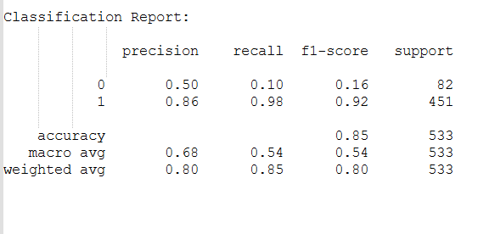

1.11 Decision Tree Classification Report. Note both reports had classification issues and resulted in many models being similar.

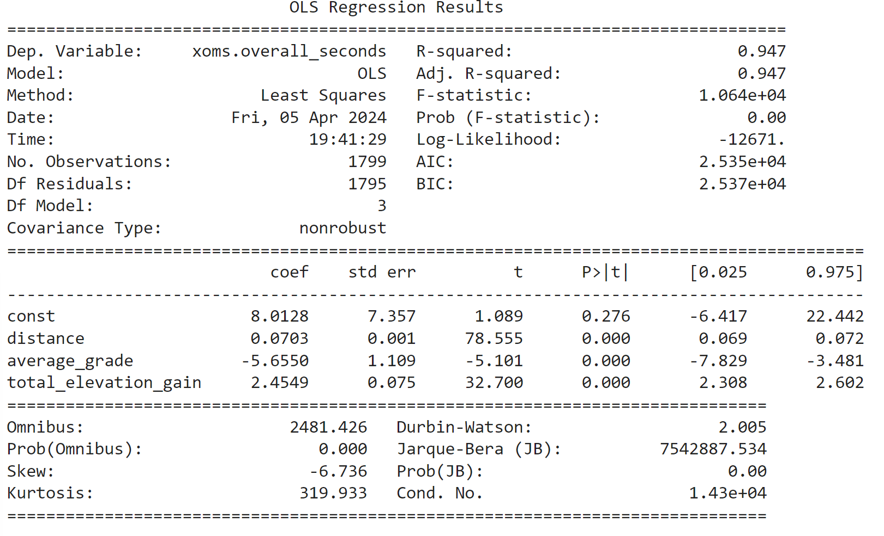

1.12 Ordinary Least Squares Regression Model to predict fastest time.

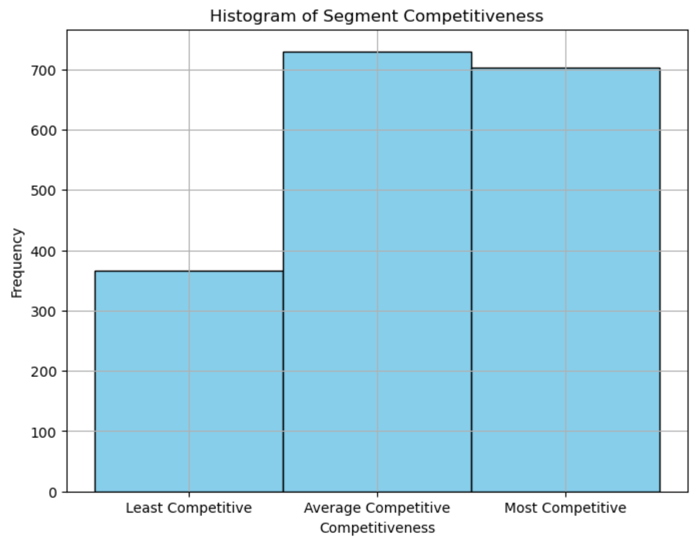

1.13 Distribution of competitiveness variable created by OLS regression

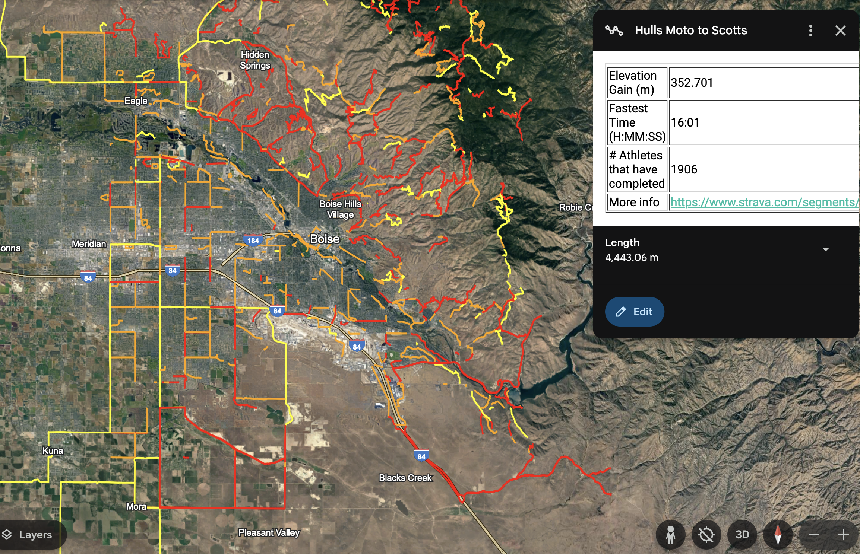

1.14 Google Earth: most competitive trails visualization

All visual presentations of data as well as code output are contained in Python .ipynb models for ease of use and access. Google Earth was utilized for further visualization, as it displayed an imported KML file generated with python code. This visualization saves those investigating our findings from having to sift through many code files. Each form of output and visual is stored directly below the related code cell to allow for understanding how the data is being manipulated to create the output.

B. Document the management of the presentation/ visualization products and any associated metadata, etc. min. 2-3 sentences (2%)

* Presentation and visualization products and associated metadata by using version control systems like Git. Collaborative platforms such as OneDrive, Google Collab, and Visual Studio were used for project management. While Metadata including our source data and parameters were documented on GitHub where the dataset originally existed. Updated forms of imports applied to the data in the forms of cross-validation metrics were used to ensure accuracy of output models.

C. Describe how your presentation/ visualization meets the goal of the investigation and highlight any value that was gained, min. 3-4 sentences (2%)

* Visualization of decision trees, and a keyhole markup language (KML) allowed our team to comprehend the relationships between key variables. Through the pair plots and confusion matrix’s insight, researchers can clearly see relationships in the dataset. After that came comparisons between model performance and feature importance, and associated plots highlighted key predictors, offering guidance on decision making and further analysis. Overall, these visualizations added significant value and enabled our team to make the best possible informed decisions and achieve a deeper understanding of the data.

4. Describe your overall data management plan for the results of questions 1, 2 and 3 using the 9 categories of data management from assignment 1, min. 1-2 sentences for each category (5%)

* Logical Collections – You can download the dataset as a single file comprising 36 columns of data. Data was collected and organized into an all-inclusive dataset. Functions applied to the combined dataset contained the same types of output to ensure ease of use and comparison of effectiveness.
* Physical Data Handling - Data was stored in a secure yet accessible location of a shared OneDrive environment. Having a collaborative cloud storage solution ensured appropriate backups and control mechanisms were applied.
* Interoperability Support – Data was stored in open source .csv file format before being imported and parsed in a Python based environment. Use of open-source datasets and tools applied ensured interoperability support and analysis tools and platforms used now and, in the future, could easily be applied.
* Security – Access controls and encryption were exercises by the standard practices of the GitHub repository where the project is stored.
* Data Ownership – Clear documentation and usage rights for the data are defined in the metadata.
* Meta Data – Data relating to data sources, preprocessing steps, model parameters, and analysis outcomes where documented and context provided for interpretation purposes for further research and reference. Metadata can be found in both the code and hosted on GitHub contains the dataset used.
* Persistence – Data was stored in a long-lasting universal format with regular local backups ensuring integrity and availability. Access was limited to the research team for the project's extent before publication to a public GitHub repository at https://github.com/26noahr/StravaProject.
* Discovery – Metadata and related data descriptions will be indexed and made searchable according to Dublin Metadata standards. This allows easy discovery and access by anyone who knows where to look for this dataset.
* Dissemination – Results and visualization will be shared through final reports, and published on the project GitHub repository, with appropriate context for future research and understanding of possible use. Raw data and analysis code will be made available to the UI CS 479/579 for further exploration and validation, in addition to being publicly available at https://github.com/26noahr/StravaProject.